Course: Basics of Computer Science
Course Code: 26COA0101

Submitted By: Name: Kanwalpreet Singh
Roll no: 2610997039

Submitted To: Ms. Deepika Sharma
RAPTOR
Lab Activity:
Imagine a team of chefs in a busy restaurant kitchen who need to develop a new recipe for a signature dish. To ensure everyone understands the cooking process and can follow it accurately, they decide to create a flowchart using the RAPTOR interface.

a) STEP: Input The chefs start by listing the ingredients and tools needed for the dish.
a) Step Output:
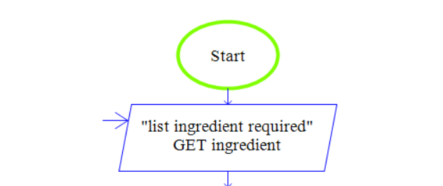

b) STEP: Process They use RAPTOR to visually outline each step of the cooking process, such as chopping vegetables, marinating meat, and cooking times.
b) Step Output:
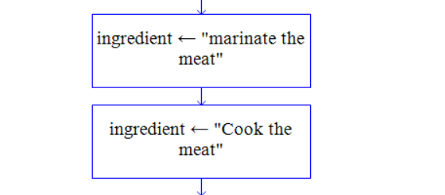

c) STEP: Decision At certain points, they include decision symbols to indicate choices, such as whether to add spices based on taste preferences.
c) Step Output:
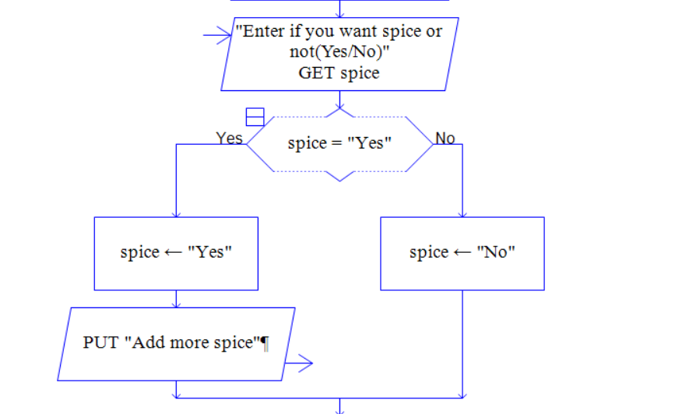
d) STEP: Output Finally, they outline the presentation of the dish.


